**COMSATS University Islamabad,   
Park Road, Chak Shahzad, Islamabad Pakistan**

SOFTWARE DESIGN DESCRIPTION

for

**Atom – Brain-Computer Interfacing using Electroencephalography**  
Version 2.0

***By***

**Kinza Arshad CIIT/FA16-BCS-108/ISB**

**Muhammad Faizan Badar CIIT/FA16-BCS-054/ISB**

***Supervisor*Dr. Yasir Faheem**

*Bachelor of Science in Computer Science (2016-2020)*

Table of Contents

1. Introduction 1

2. Design Methodology and Software Process Model 1

2.1 Architectural Design 1

2.2 Process Flow/Representation 2

3. Design Models 7

3.1 Use Case Models 7

3.2 Sequence Diagrams 11

3.3 Class Diagram 15

4. Data Design 17

4.1 Data Dictionary 22

5. Algorithm & Implementation 23

6. Software requirements traceability matrix 27

7. Human interface design 33

8.2 Screen objects and actions 33

8. Conclusion 39

Table of Architecture Model(s)

**Architectural Model 1** Atom in MVC 2

Table of Activity Diagrams

**Activity Diagram 1** Account Handling Module 3

**Activity Diagram 2** User Analytics and Statistics 4

**Activity Diagram 3** Specialized Control Training 5

**Activity Diagram 4** Entertainment Incentivized Training 6

Table of Use case Models

**Use case Model 1** Account Handling module 7

**Use case Model 2** User Analytics and Statistics module 8

**Use case Model 3** Specialized Control Training module 8

**Use case Model 4** Entertainment Incentivized Training module 9

**Use case Model 5** EEG Feature Extraction module 10

**Use case Model 6** Database Handling module 10

Table of Sequence Diagrams

**Sequence Diagram 1** Preliminary use cases 12

**Sequence Diagram 2** User Analytics and Statistics use cases 14

**Sequence Diagram 3** Specialized Control Training use cases 14

**Sequence Diagram 4**  Entertainment Incentivized Training use cases 15

Table of Screenshots

**Interface 1** Register Activity 33

**Interface 2** Dashboard Activity 34

**Interface 3** Drawer Activity 35

**Interface 4** Bookshelf Activity 36

**Interface 5** Book Reader Activity 37

Revision History

|  |  |  |  |
| --- | --- | --- | --- |
| **Name** | **Date** | **Reason for changes** | **Version** |
| Dr. Yasir Faheem (Supervisor) | 4th December, 2019 | * Inclusion of comments from previous evaluation * Image labelling according to type of Model/Diagram/Figure * Description of text covered under any particular heading * Add conclusion to the document | 1.0 |
| FYP – I Committee | 14th December, 2019 |  |  |

**Application Evaluation History**

|  |  |
| --- | --- |
| **Comments (by committee)**  **\*include the ones given at scope time both in doc and presentation** | **Action Taken** |
| * Related system Analysis spacing | Added some space above the table |
| * Following modules lack specificity: * Account Handling module * Specialized Control Training module * EEG Feature Extraction module * Database handling module | Added more specifics on each and every one of the modules |
| * Use case diagrams not according to convention | Followed Sommerville convention for the use case diagrams by keeping action lines outside the boundaries and limiting complex models |
| * Missing captions from use case tables | Added captions to use case tables |
| * Incomplete functional requirements | Added more definition to the requirements |
| * Blank page in the document | Blank pages removed |
| * Fixes for activity diagrams:   Account Handling activity diagram branch usage instead of fork/merge  User Analytics and Statistics activity diagram redundant processes  Boundary inclusion in Use case models  Sequence diagrams positioning and rotational fixes | Activity diagrams fixed |
| * Revise Class Diagrams for new updated implementation | Revisions made |

Supervised by

Dr. Yasir Faheem

**Signature____________________**

# Introduction

Our project deals with the domain of Brain-Computer interface and Cognitive Electrophysiology. As the name suggests it uses brain to give input and reads its input by tapping into the electric mode pf communication that our neuron use to communicate all the thoughts and functionalities, we are able to perform. The field is growing, and the possibilities are endless. The fundamental idea is to use this EEG incorporated BCI to target issues relating to human activities, specifically enhancing the attention span to improve focus in daily activities such as reading and others with similar brain involvement. The methodology we’ve chosen to achieve said claim can be divided into two streams; entertainment incentivized training and specialized controlled training, achieved by mini-games and a book reader respectively, where-in both these utilities are taken use of by the BCI to be built

This document will specify the hardware and the software aspects while also discussing the compatibility of different platforms and the integration of different modules that come together to make the whole project.

# Design Methodology and Software Process Model

Since this project belongs to the same framework of research to the branches of Human-Computer Interaction like Social Networking, Augmented Reality, etc., our design methodology is primarily based around the focus of keeping the entire design user-experience-centric. It should pertain to accessibility, easy intractability, and minimalistic user interface provision. Regarding the process model, the software we are supposed to build is in close interaction with uncommon hardware and a rarely used peripheral device i.e. the brain, we are working in an Agile Development process model where our focus is on immediate prototype deployment and simultaneous self-induced testing and criticism.

**System Overview**

Since the primary choice to deploy Atom is to release an application or software on a platform which a mass majority of users are comfortable and familiar with, we’ve streamlined production on smartphone and due to technical barriers, the pre-dominant choice is Android. According to convention, Android targeted software are inherently followers of the Model-View-Controller paradigm, and in addition to that, the below diagram begins to concretize by providing further insight into each block. An implied improvisation on this architecture is the inclusion of the headset with the controller and not allocating another block for the peripheral to prevent breaking standard convention, although an accurate visualization might consider this as a separate block.

## Architectural Design

The following presents the block diagram of Atom:

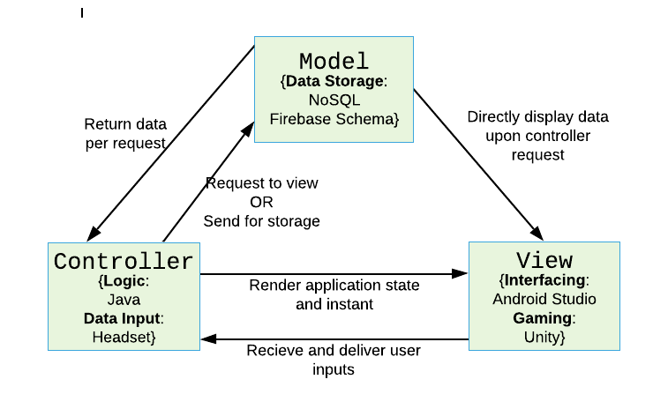

**Architectural Model 1** Atom in MVC

## Process Flow/Representation

The following section will provide Activity Diagrams for specific actions that the user can conduct based on the specific modules:

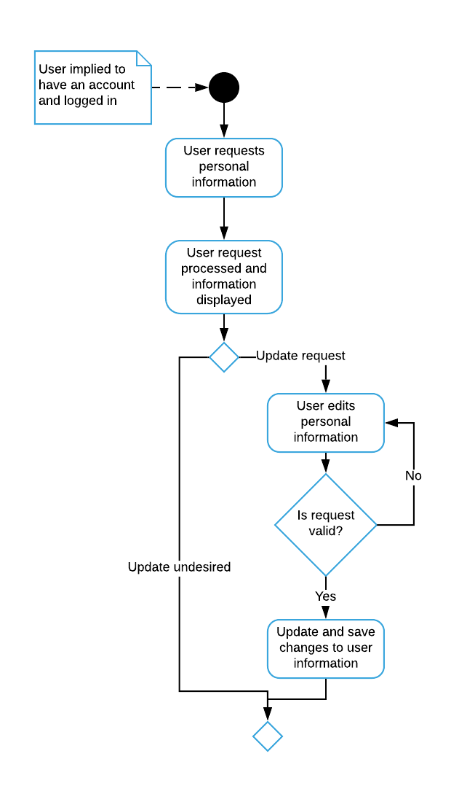

**Activity Diagram 1** Account Handling Module

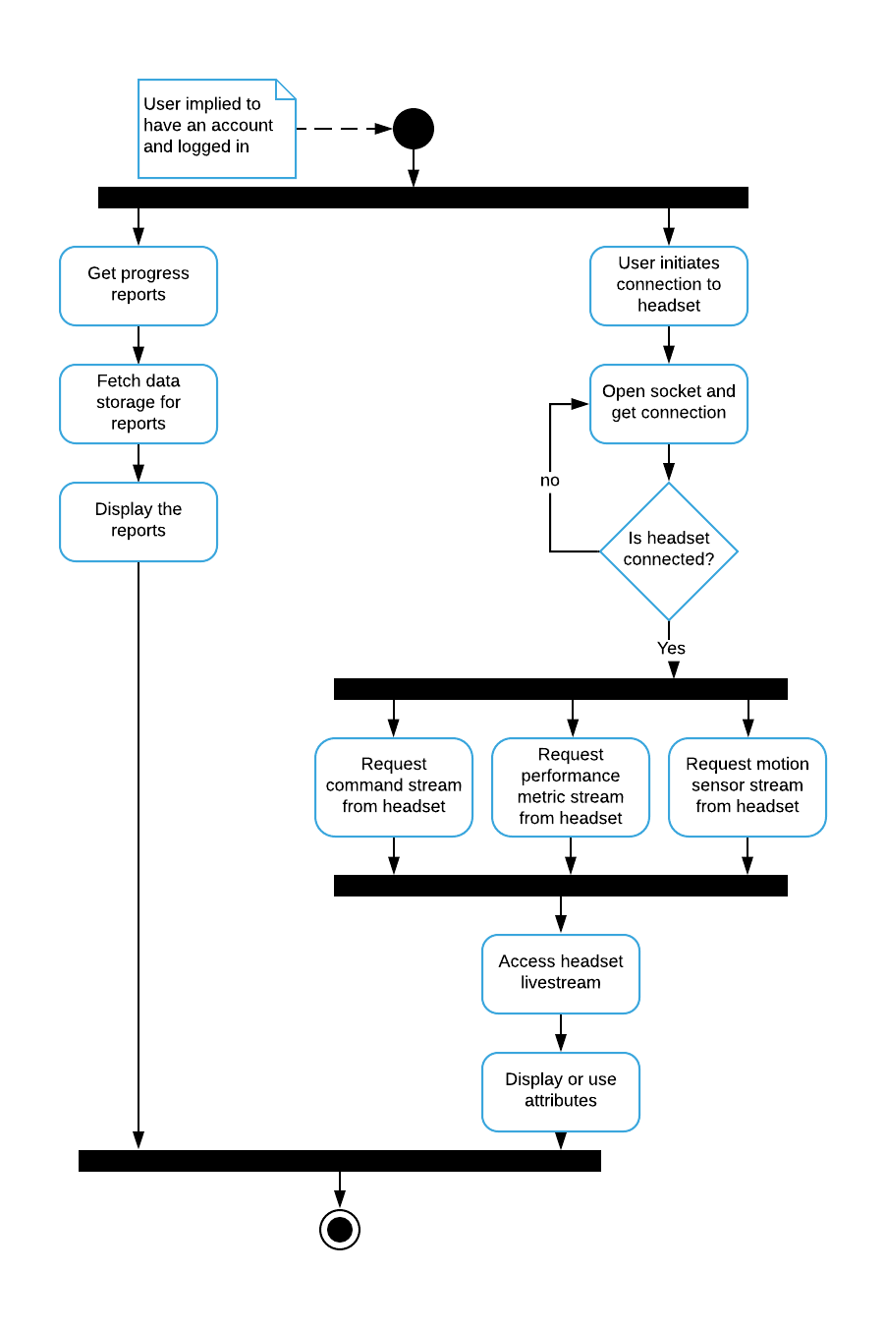

**Activity Diagram 2** User Analytics and Statistics

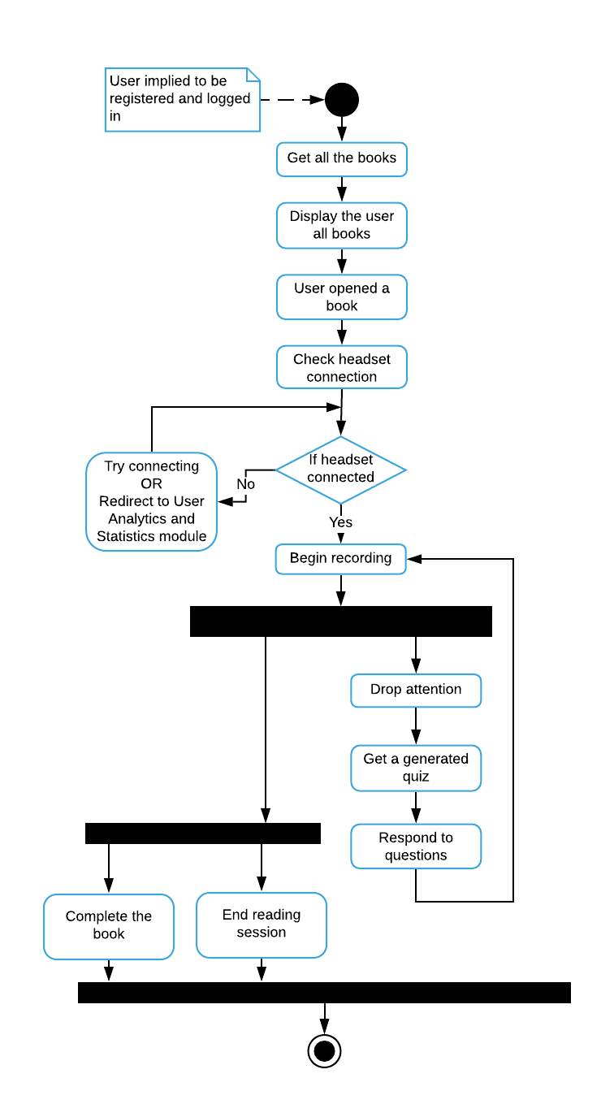

**Activity Diagram 3** Specialized Control Training

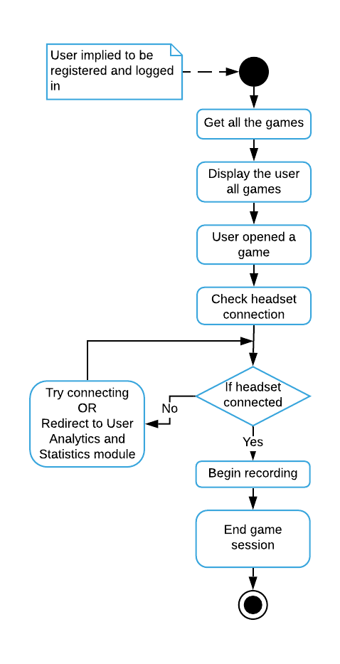

**Activity Diagram 4** Entertainment Incentivized Training

# Design Models

In consideration of the previous models and to further clear away the design abstraction, the following section presents:

* Use case Models
* Sequence Diagrams
* Class Diagram

## Use Case Models

The use case models of Atom:

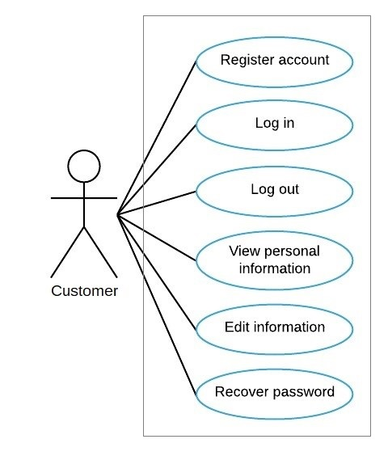

**Use case Model 1** Account Handling module

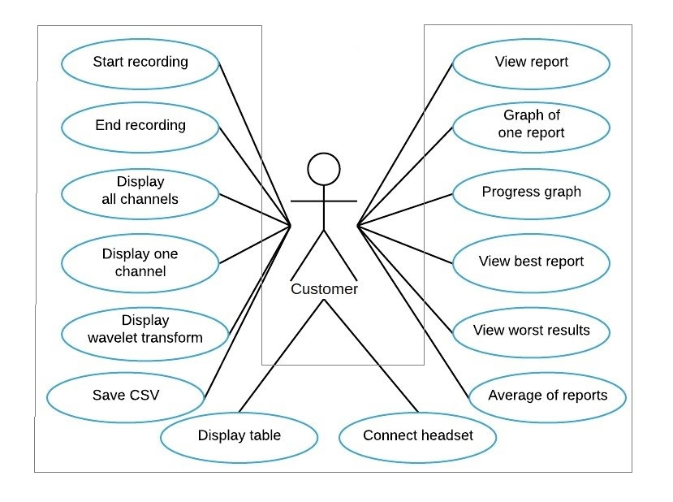

**Use case Model 2** User Analytics and Statistics module

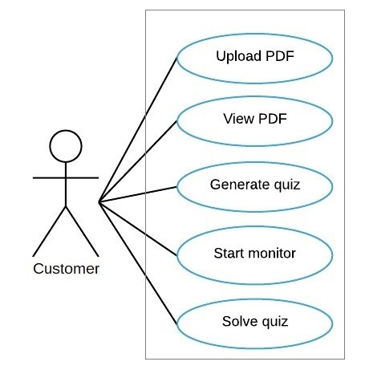

**Use case Model 3** Specialized Control Training module

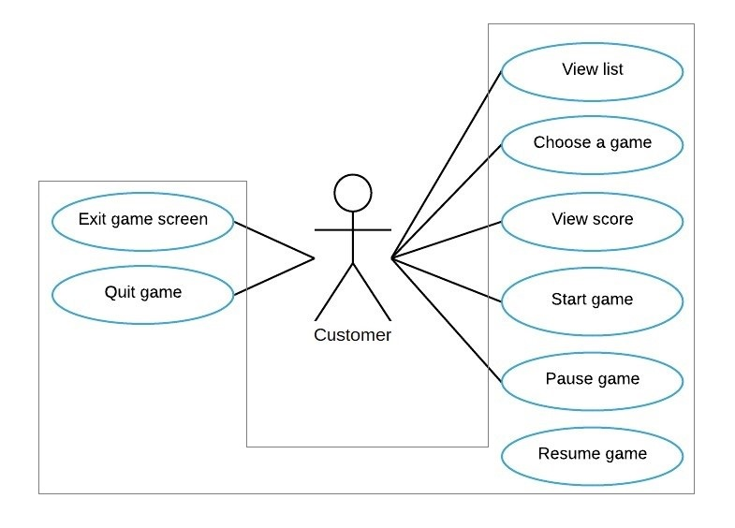

**Use case Model 4** Entertainment Incentivized Training module

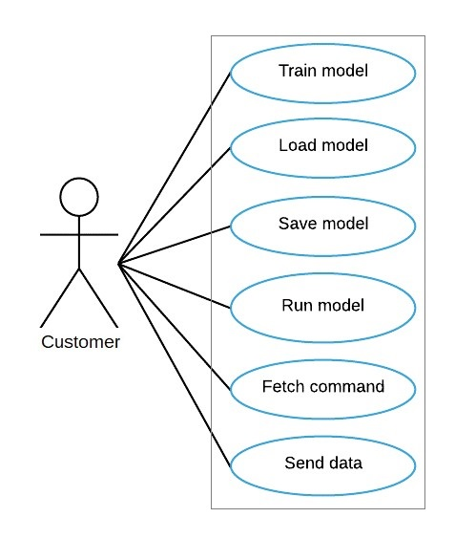

**Use case Model 5** EEG Feature Extraction module

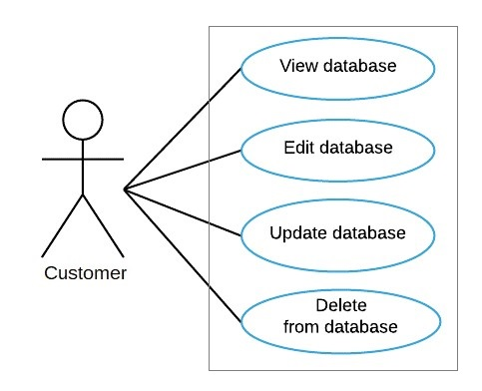

**Use case Model 6** Database Handling module

## Sequence Diagrams

The sequence diagrams of Atom:

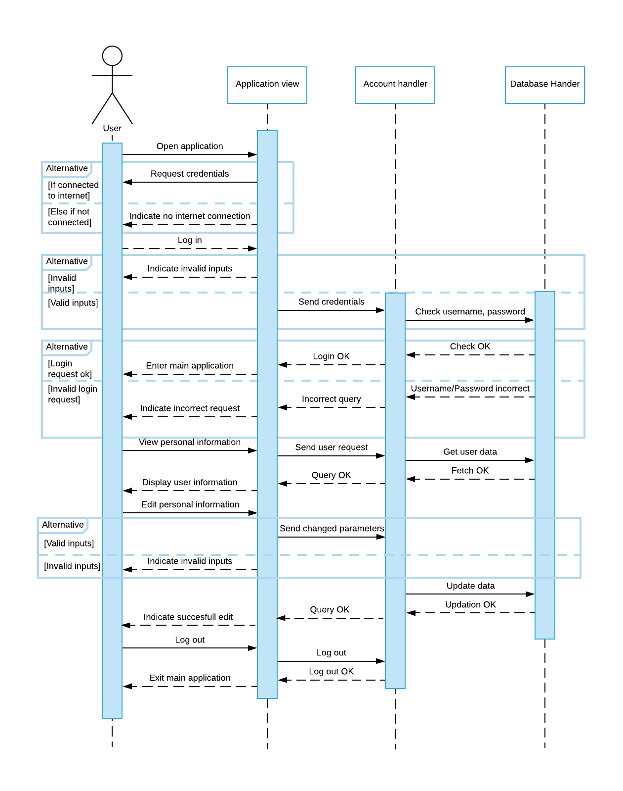

**Sequence Diagram 1** Preliminary use cases

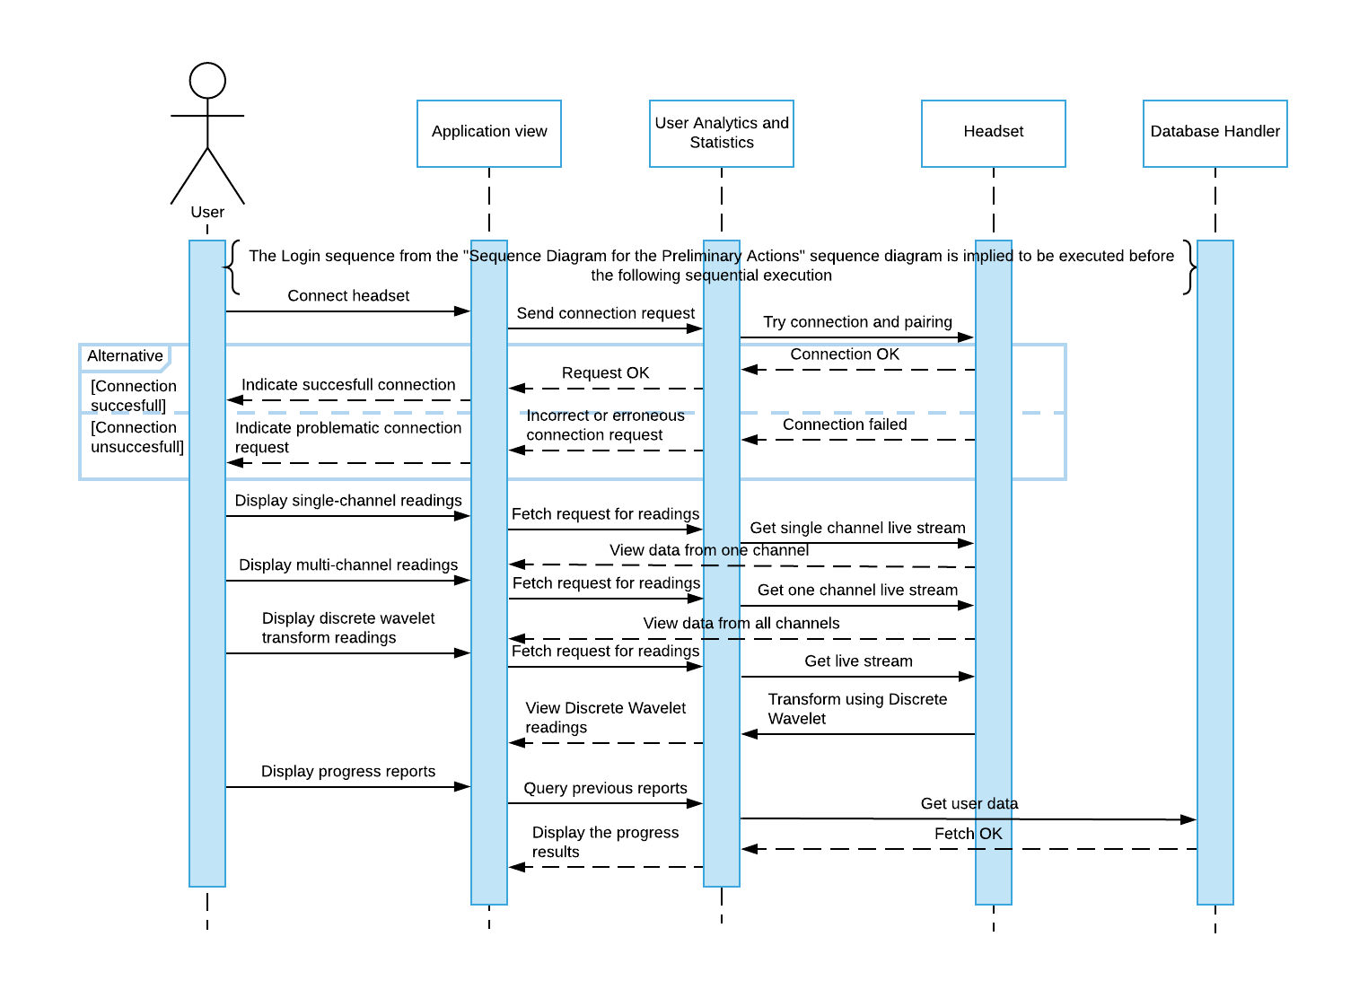

**Sequence Diagram 2** User Analytics and Statistics use cases

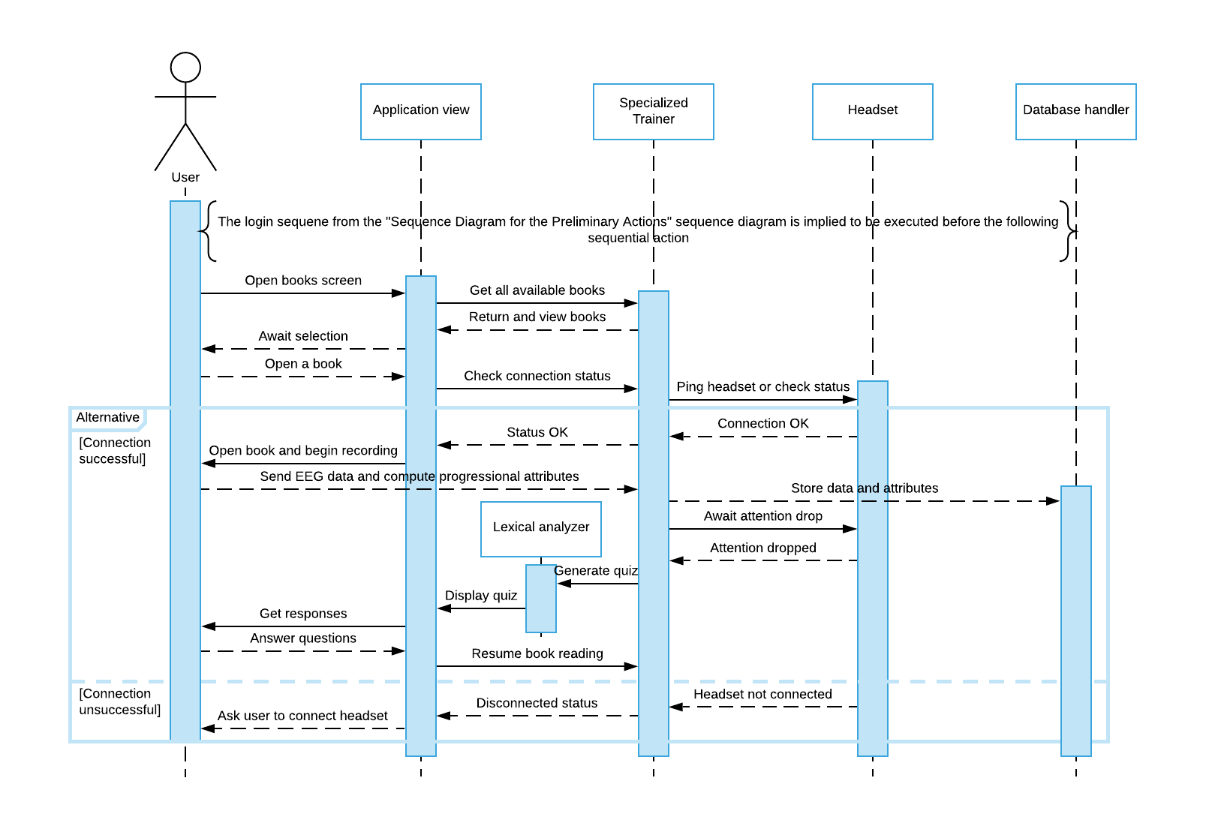

**Sequence Diagram 3** Specialized Control Training use cases

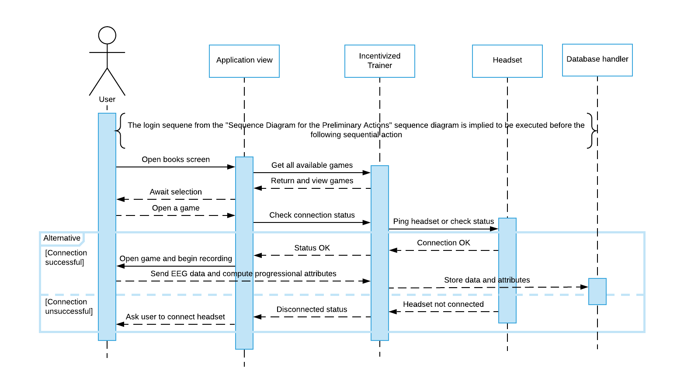

**Sequence Diagram 4**  Entertainment Incentivized Training use cases

## Class Diagram

The class diagram for the Android application for Atom:

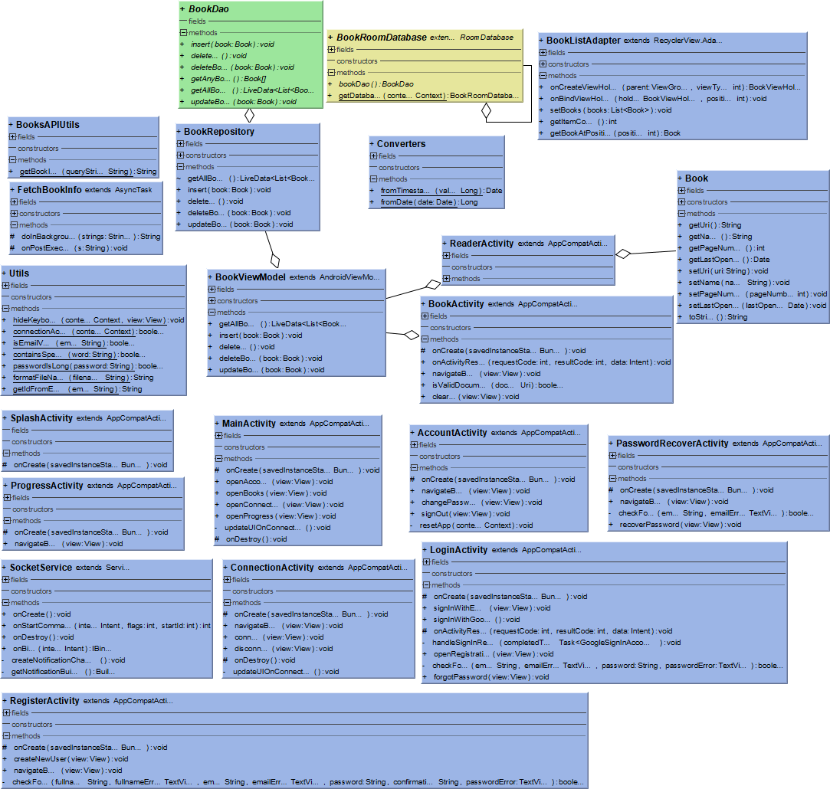

**Class Diagram 1** Atom Class Diagram – Android End

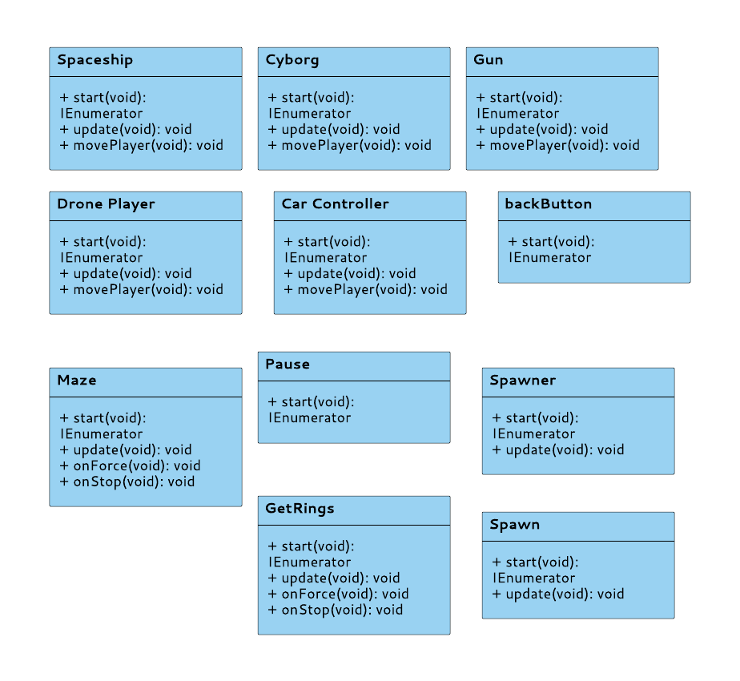

**Class Diagram 2** Class Diagram for Atom - Unity End

# Data Design

This section contains the JSON schema as an alternative to ERD Diagram since the storage mechanism that will be used is a NoSQL Storage Methodology:

{

{

**“$schema”** : “ “ ,

**“$id”** : ,

**“Title”** : “Users” ,

**“description”** : “all the accounts created”,

**“Type” : “object”,**

**“Properties” :**

**{**

“Username” : {

“Description” : “name of the user”,

“Type” : “String”

}

“Email” : {

“Description” : “email of the user”,

“Type” : “String”

}

“Password” : {

“Description” : “password for the authentication”,

“Type” : “varchar”

}

“Contact” : {

“Description” : “phone number of the user”,

“Type” : “num”

}

“profileImg” : {

“Description” : “picture of the user”,

“Type” : “Jpg , png”

}

**},**

**“Required” : [“username”, “email”, “password” , “contact” ]**

**}**

**{**

**“$schema” : ,**

**“$id” : ,**

**“Title” : “Admin” ,**

**“description” : “all the accounts of admins”,**

**“Type” : “object”,**

**“Properties” :{**

“AdminID” : {

“Description” : “Id assigned by the system for admin access”,

“Type” : “String”

}

“AdminPass” : {

“Description” : “password for admin authentication”,

“Type” : “varchar”

}

**},**

**“Required” : [“adminID”, “adminPass” ]**

**}**

**{**

**“$schema” : “ “ ,**

**“$id” : ,**

**“Title” : “Games” ,**

**“description” : “all the games in the application”,**

**“Type” : “object”,**

**“Properties” :{**

“gameName” : {

“Description” : “name of the game”,

“Type” : “string”

}

“gameID” : {

“Description” : “random ID assigned to the game”,

“Type” : “num”

}

**},**

**“Required” : [“gameName”, “gameID” ]**

**}**

**{**

**“$schema” : “ “ ,**

**“$id” : ,**

**“Title” : “Scores” ,**

**“description” : “scores recorded of all the users ”,**

**“Type” : “object”,**

**“Properties” :**

**{**

**“**Username” : {

“Description” : “name of the user”,

“Type” : “string”

}

“gameID” : {

“Description” : “ID of the game ”,

“Type” : “num”

}

“Score” : {

“Description” : “score of the user ”,

“Type” : “num”

}

**},**

**“Required” : [“username”, “gameID” , “score” ]**

**}**

**{**

**“$schema” : “ “ ,**

**“$id” : ,**

**“Title” : “Recordings” ,**

**“description” : “all the recording files”,**

**“Type” : “object”,**

**“Properties” :{**

“userName” : {

“Description” : “name of the user”,

“Type” : “string”

}

“recordingID : {

“Description” : “random ID assigned to the file by system”,

“Type” : “num”

}

“recordingLink” : {

“Description” : “link of the file uploaded in the database storage”,

“Type” : “string”

}

**},**

**“Required” : [“username”, “recordingID” , “recordingLink” ]**

**}**

**}**

## Data Dictionary

|  |  |  |  |  |  |
| --- | --- | --- | --- | --- | --- |
| **FieldName** | **DataType** | **DataFormat** | **FieldSize** | **Description** | **Example** |
| username | string | text | Not specified | Full name of the user | “Kinza arshad” |
| email | string | text | Not specified | Email of the user | “maida@gmail” |
| password | VarChar | text | Not specified | Password for user authentication | “mustafa” |
| contact | num | text | Not specified | Phone number of the user | “03321576652” |
| profileImg | String | text | Not specified | Link of the profile uploaded on the database storage | “ “ |
| adminId | String | text | Not specified | Id assigned by the developers to the admins | “kinza@gmail” |
| adminPass | VarChar | text | Not specified | Admin password assigned to adminID for authentication | 13718847262” |
| gameName | String | text | Not specified | Name of all the games in the application | “ball_jump” |
| gameID | num | text | Not specified | Game ID assigned to the game to identify it | “01’ |
| score | num | text | Not specified | Score to keep track of progress of the users | “20” |
| recordingID | num | text | Not specified | RandomID assigned by the system to the recording file | “0318487101” |
| recordingLink | String | text | Not specified | link of the file  In the storage | “ “ |

# Algorithm & Implementation

The major algorithms in form of pseudocode:

**KNN:**

Classify(X,Y,x)

X= training data

Y= class labels of X

x= unknown sample

For i =1 to m

Compute Distance d(Xi , x)

Compute set I containing indices for the k smallest distances d(Xi , x)

Return majority label for {Yi where i belongs to I)

**DWT:**

Public static int[ ] discreteWaveletTransform( int[ ] input){

//this function assumes that input.length= 2^n , n>1

Int[ ] output = new int[ input.length ];

For (int length = input.length / 2 & length= length/2){

//length is the current length of the working area of the output array

//length starts at half of the array size and every iteration is halved until it is 1

For (int i=0 ; i<length ; ++i){

Int sum= input[ i*2 ] + input[ i*2+1 ];

Int difference= input[ i*2 ] - input[ i*2+1 ];

Output[ i ]= sum;

Output[ length+i ]= difference;

}

if(length == 1){

Return output;

}

system.arraycopy(output,0,input , 0, length);

}

}

For i in range (X):

coeffs= discreteWaveletTransform(X)

cA1 , cD1= coeffs

coeffs2= discreteWaveletTransform( cA1)

cA2, cD2 = coeffs2

coeffs3= discreteWaveletTransform( cA2 )

cA3 , cD3= coeffs3

coeffs4= discreteWaveletTransform(X)

cA4 , cD4= coeffs4

coeffs5= discreteWaveletTransform( cA4 )

cA5 cD5= coeffs5

For j in range(16):

Processed [ i ] [ j ] [ 0 ] = cA5[ j ]

Processed [ i ] [ j ] [ 1 ] = cD1[ j ]

Processed [ i ] [ j ] [ 2 ] = cD2[ j ]

Processed [ i ] [ j ] [ 3 ] = cD3[ j ]

Processed [ i ] [ j ] [ 4 ] = cD4[ j ]

Processed [ i ] [ j ] [ 5 ] = cD5[ j ]

**GAME:**

//updata is called once per frame

Void update(){

readData();

//makePieces();

for( int i=0 ; i<Input.touchCount ; i++){

if(Input.GetTouch(i).phase == TouchPhase.Began){

//construct a ray from current touch coordinates

transform.Translate( 0, 2, 0);

}

}

}

Void readData(){

//read data from the port

}

Int makePieces(){

// make the pieces in to 500 rows to make small samples

Int r= callModel(tempArray);

Return r;

}

Int callModel(Array tempArray){

//call the model and get input

Return 1;

}

**PDFViewer:**

//Declare buttons

//open default ACTION_GET_CONTENT from android to select pdf

//create chooser

//get result code and check if it is OK

//load pdf

**Sign-in:**

//initialize the buttons

//initialize Paper(remembers username and password) library

//set up the onClicks on buttons

//get the text from the EditTexts

//check if the information user entered is null

//remember the username and password on Paper

//initialize firebase database

//check if the table Users exists

//check if the email exists

//check if the password is correct

**Sign-up :**

//initialize the buttons

//initialize Paper(remembers username and password) library

//set up the onClicks on buttons

//get the text from the EditTexts

//check if the information user entered is null

//initialize firebase database

//check if the table Users exists

//check if the email exists

//start the default ACTION_GET_CONTENT for GalleryPick

//if pic upload is successful then upload it to database storage

//create a HashMap of all the data

//upload the data on database

//If upload is successful then start activity login

//remember the username and password on Paper

# Software requirements traceability matrix

This section should contain a table that summarises how each software requirement has been met in this document. The tabular format permits one-to-one and one-to-many relationships to be shown.

Table 1 Requirements Traceability Matrix

|  |  |  |  |
| --- | --- | --- | --- |
| **Req. Number** | **Ref. Item** | **Design Component** | **Component Items** |
| FR01 | Sign-in | register | onClick() |
| FR02 | Sign-up | register | createAccount()  validateInformation() |
| FR03 | Name | register | oncreate()  createAccount() |
| FR04 | Email | register | oncreate()  createAccount() |
| FR05 | Password | register | oncreate()  createAccount() |
| FR06 | Contact | register | oncreate()  createAccount() |
|  | Profile | register | oncreate()  uploadImg() |
| FR07 | Database Input | register | validateInformation() |
| FR08 | Success-Register | register | validateInformation() |
| FR09 | Failure-Register | register | validateInformation() |
| FR10 | Logout | HomeFragment | onCreate()  onClick() |
| FR11 | Edit | header_file | onCreate()  onClick() |
| FR12 | Name-Edit | edit | onCreate() |
| FR13 | Email-Edit | edit | onCreate() |
| FR14 | Password-Edit | edit | onCreate() |
| FR15 | Contact-Edit | edit | onCreate() |
| FR16 | Confirm-Edit | edit | onCreate() |
| FR17 | Database-update | edit | onCreate()  editInformation() |
| FR18 | Success-Edit | edit | onCreate()  editInformation() |
| FR19 | Failure-Edit | edit | onCreate()  editInformation() |
| FR20 | View | HomeFragment | onCreate()  onClick() |
| FR21 | List-View | userAnalytics | onCrete()  onClick() |
| FR22 | View-Button | userAnalytics | onCreate()  onClick() |
| FR23 | Display-Reports | userAnalytics | onCreate()  onClick()  displayReports() |
| FR24 | Sign-in | MainActivity | onCreate()  onClick() |
| FR25 | Sign-up | MainActivity | onCreate()  onClick() |
| FR26 | Email | MainActivity | onCreate() |
| FR27 | Password | MainActivity | onCreate() |
| FR28 | Success-Login | MainActivity | onCreate()  LoginUser()  AllowAccessToAccount() |
| FR29 | Failure-Login | MainActivity | onCreate()  LoginUser()  AllowAccessToAccount() |
| FR30 | Slide profile | Dashboard() | onCreate()  setInformation() |
| FR31 | Forgot password | MainActivity | onCreate()  onClick() |
| FR32 | Recovery email | recovery | onCreate() |
| FR33 | New password | recovery | onCreate() |
| FR34 | Confirm-password | recovery | onCreate()  generateNewPassword() |
| FR35 | graph | userAnalytics | GenerateGraph() |
| FR36 | Progress graph | userAnalytics | generateProgressGraph() |
| FR37 | Display-EEG | userAnalytics | displayEEG() |
| FR38 | View-worst | reports | onCreate()  onClick() |
| FR39 | Average-reports | reports | onCreate()  onClick() |
| FR40 | Display-Channels | userAnalytics | onCreate()  onClick() |
| FR41 | Channels | userAnalytics | displayChannels() |
| FR42 | Start-Recording | recordingEEG | startRecord() |
| FR43 | Pause-Recording | recordingEEG | pauseRecord() |
| FR44 | End-Recording | recordingEEG | endRecord() |
| FR45 | DWT | userAnalytics | onCreate()  onClick() |
| FR46 | Save-csv | recordingEEG | Save() |
| FR47 | Success-save | recordingEEG | Save() |
| FR48 | Failure-save | recordingEEG | Save() |
| FR49 | Table | userAnalytics | generateTable() |
| FR50 | Connect | headsetSettings | Connect() |
| FR51 | Dis-connect | headsetSettings | Dis-connect() |
| FR52 | Success-headset | headsetSettings | Connect() |
| FR53 | Failure-connect | headsetSettings | Connect() |
| FR54 | Start-exploring | bookshelf | onCreate()  onClick() |
| FR55 | Open-gallery | bookshelf | onCreate()  onClick() |
| FR56 | Click-file | bookshelf | onCreate()  onClick() |
| FR57 | Scrollable-pdf-display | bookshelf | onActivityResult() |
| FR58 | Generate-quiz | bookshelf | onCreate()  onClick() |
| FR59 | Display-quiz | quiz | generateQuiz() |
| FR60 | Monitor | bookshelf | onActivityResult() |
| FR61 | Success-monitor | bookshelf | onActivityResult() |
| FR62 | Failure-monitor | bookshelf | onActivityResult() |
| FR63 | Solve-quiz | DisplayQuiz | onCreate()  onClick() |
| FR64 | Display-question | DisplayQuiz | onCreate()  onClick() |
| FR65 | Choose-quiz-option | DisplayQuiz | onCreate()  onItemClickListener() |
| FR66 | done | DisplayQuiz | onCreate()  onClick() |
| FR67 | Display-scores | DisplayQuiz | onCreate()  onClick()  displayScores() |
| FR68 | Save-score | quiz | onCreate()  onClick()  saveScore() |
| FR69 | View-list | HomeFragment | onCreate()  onClick() |
| FR70 | Display-gamelist | games | diaplayGames() |
| FR71 | View-score | unityActivity | getLatestScore() |
| FR72 | Display-gamescore | games | onCreate()  onClick()  getScores() |
| FR73 | Pause-game | player | Update()  Pause() |
| FR74 | Start-game | player | Update()  Start() |
| FR75 | Touch-Input | unityActivity | Update() |
| FR76 | Headset-Input | player | Update()  getData()  makePeices() |
| FR77 | Resume-game | player | Update()  Resume() |
| FR78 | Quit-game | player | Update()  Quit() |
| FR79 | Exit-game-screen | player | Update()  Back() |
| FR80 |  |  |  |
| FR81 | Delete-database | adminHome | onItemClickListener()  delete() |
| FR82 | Success-database-delete | adminHome | onItemClickListener()  delete() |
| FR83 | Failure-database-delete | adminHome | onItemClickListener()  delete() |
| FR84 | View-database | adminHome | getData()  display() |
| FR85 | Failure-database-view | adminHome | getData()  display() |
| FR86 | Update-database | adminHome | onItemClickListener()  update() |
| FR87 | Success-database-update | adminHome | update() |
| FR88 | Failure-database-update | adminHome | update() |
| FR89 | Edit-database | adminHome | onItemClickListener()  edit() |
| FR90 | Success-database-edit | adminHome | Edit()e |
| FR91 | Failure-database-edit | adminHome | Edit() |

# Human interface design

This section is a view into the primary build of the working application interfaces:

## 8.2 Screen objects and actions

**registerActivity:**

This activity has inputs in the from of EditTexts and ImageView .It allows you to pick an image from the gallery and add name, email, password, contact . when sign-up is pressed a new user is created in the database and login activity is opened. If the user already has an account he/she can click sign-in button and go back to sign-in activity.



**Interface 1** Register Activity

**sign-in Activity:**

This activity has inputs in the form of EditTexts to enter an already existing account. When the user presses sign-in , the system authenticates the username and password from the database and if the authentication is successful takes the user to the Dashboard . If the user doesn’t have an account he/she can click sign-up and go to the sign-up page to register.

**Dashboard Activity:**

This activity has two ImageView buttons that take us to the reading exercise and the gaming exercise which are the core features of our application .The headset icon on the top right shows if the headset is connected or not . The buttons on the bottom are User Analytics , Headset Settings , Log-out . The User Analytics button takes us to an activity which lets us view the data in different formats . The Headset Settings opens an activity that lets us see the connection status and signal strength with our headset. The logout buttons logs the system out and deletes data from the paper.

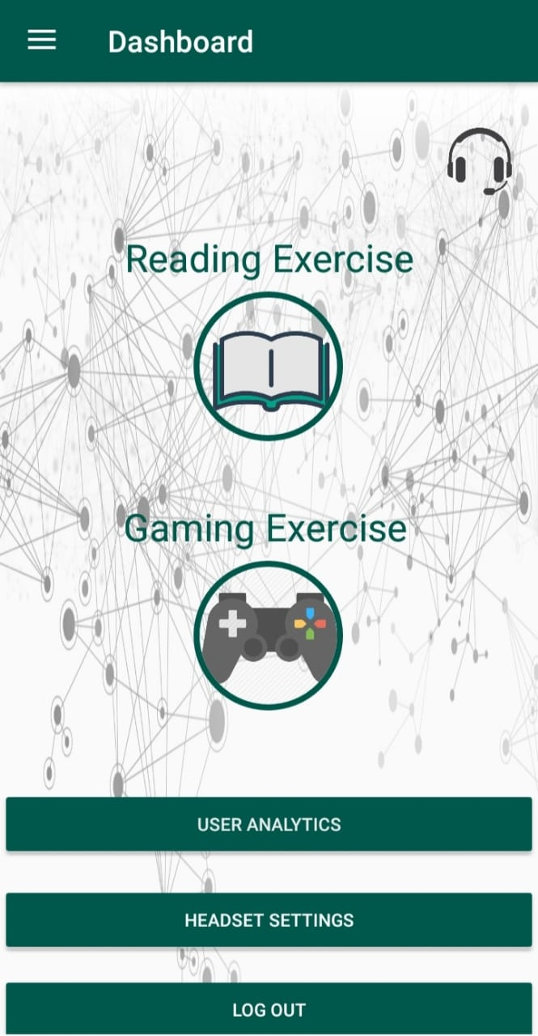

**Interface 2** Dashboard Activity

**Drawer Activity:**

This activity has all the Profile information . It gets all the data from from the firebase database in realtime against the username that is logged-in.

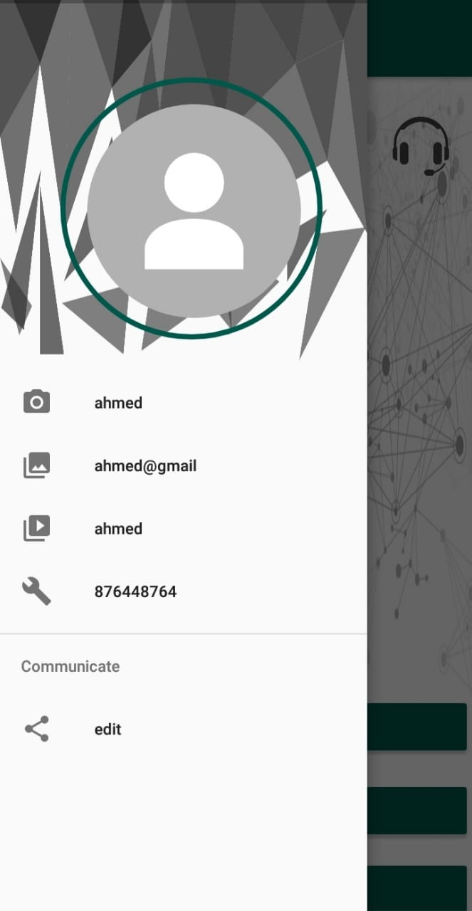

**Interface 3** Drawer Activity

**Bookshelf Activity:**

This activity has one button that calls the default choose file action to let the user choose a .pdf file.



**Interface 4** Bookshelf Activity

**PDFViewer Activity:**

This activity loads the pdf from the page one and lets the user scroll the pdf file .

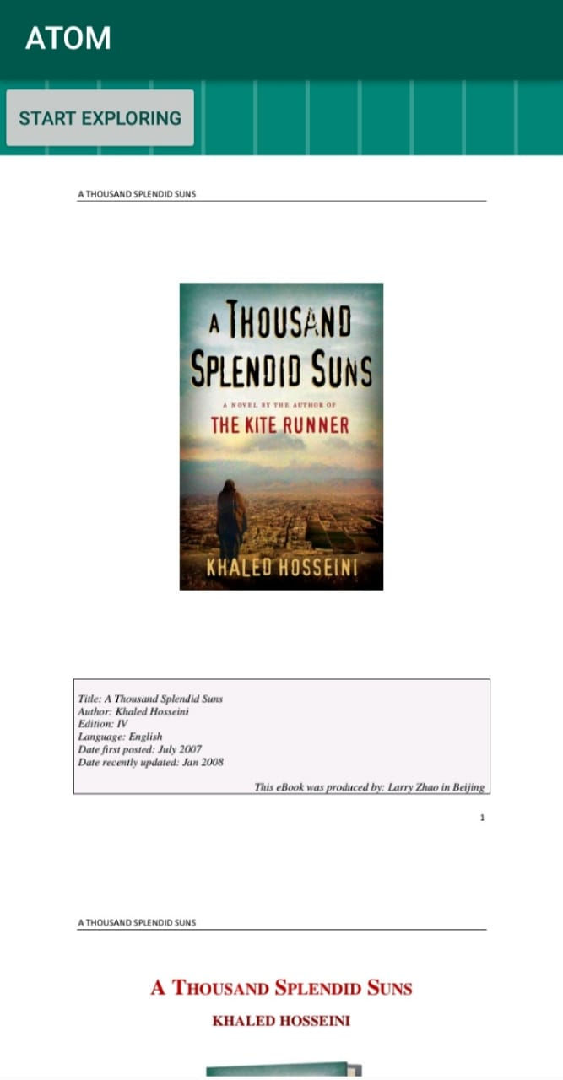

**Interface 5** Book Reader Activity

**GameList Activity:**

This activity has the Icons of all the games in the listformat . on click the icon takes the user to a unity activity so he/she can play the game.



**Interface 6** Game List Activity

**Game:**

This activity has the game with a ball that can jump.

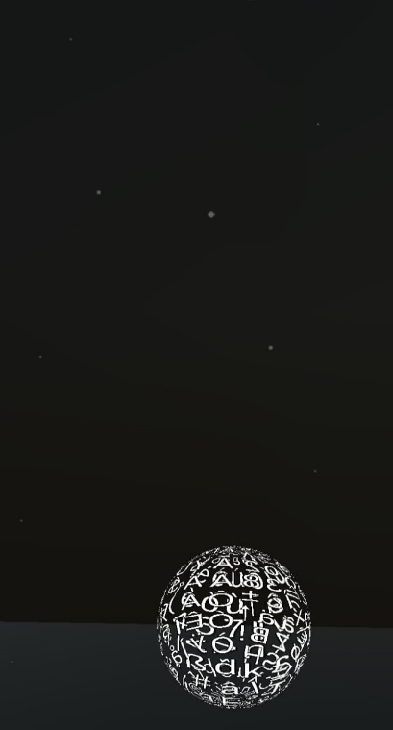

**Interface 7** Game Activity

**Headset Settings:**

This activity shows the connection status and signal strength . It also provides with two buttons connect and disconnect from the headset.

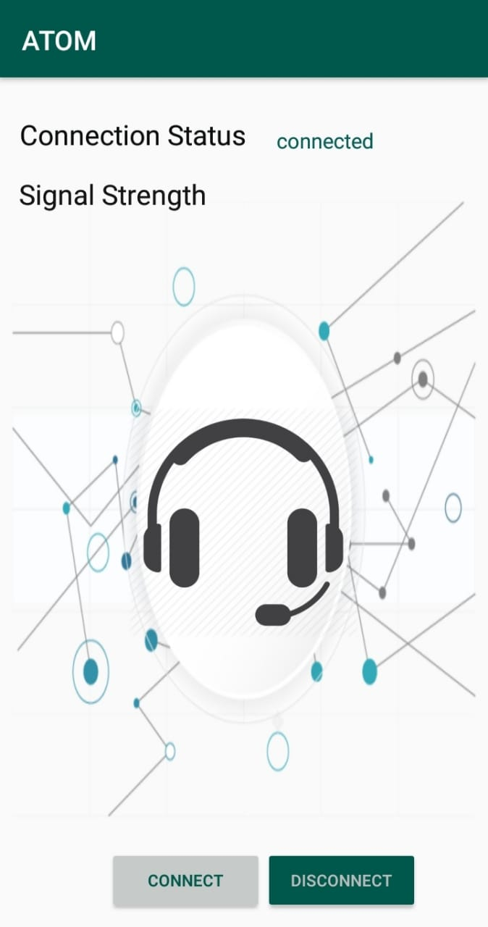

**Interface 8** Headset Settings Activity

# Conclusion

The document tends to present and define the design specification of Atom. It defines the high-level Architecture of the application using the Architectural block diagram up to the low level sequences and activities using the corresponding diagrams and concretizes code using the class diagram presented and the algorithms and implementation techniques presented above. This document will be used as a standpoint for further development into the project leading into a stable and compelling application.